**Estrutura de um protocolo**

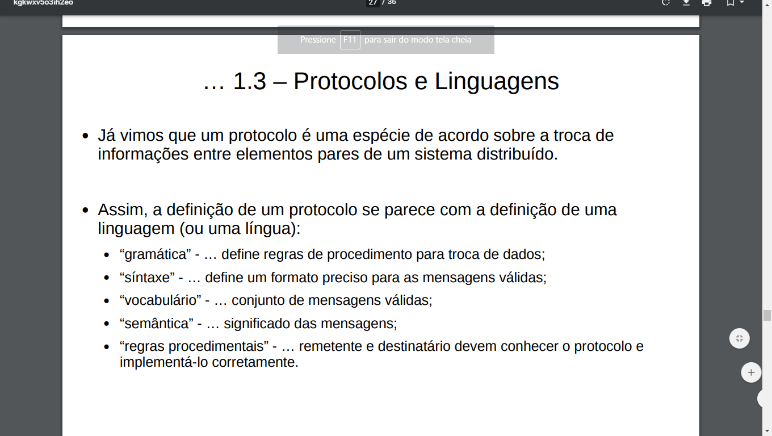

Um protocolo é maneira de troca de informação entre sistemas distribuídos

Se interpretado de forma errada pode causar algo muito grave

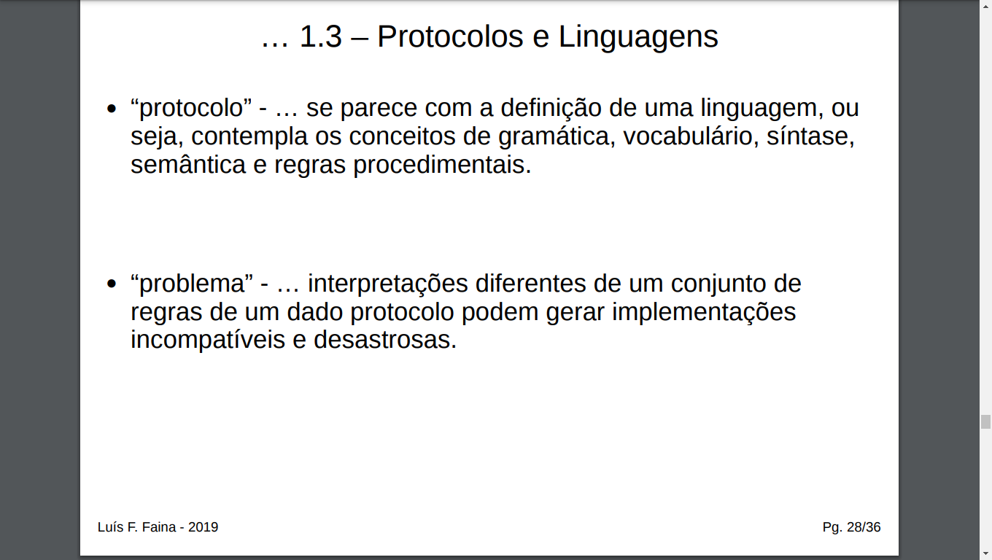

Entidades de padronização de um protocolo

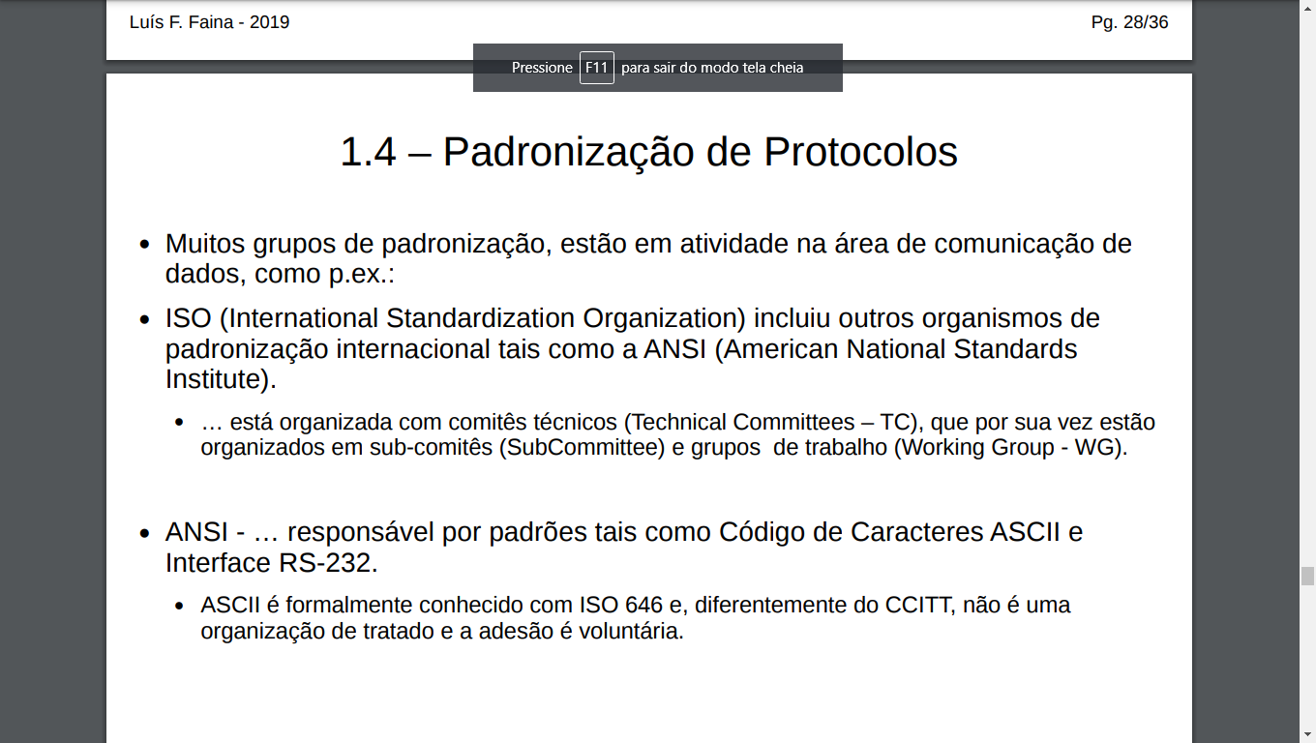

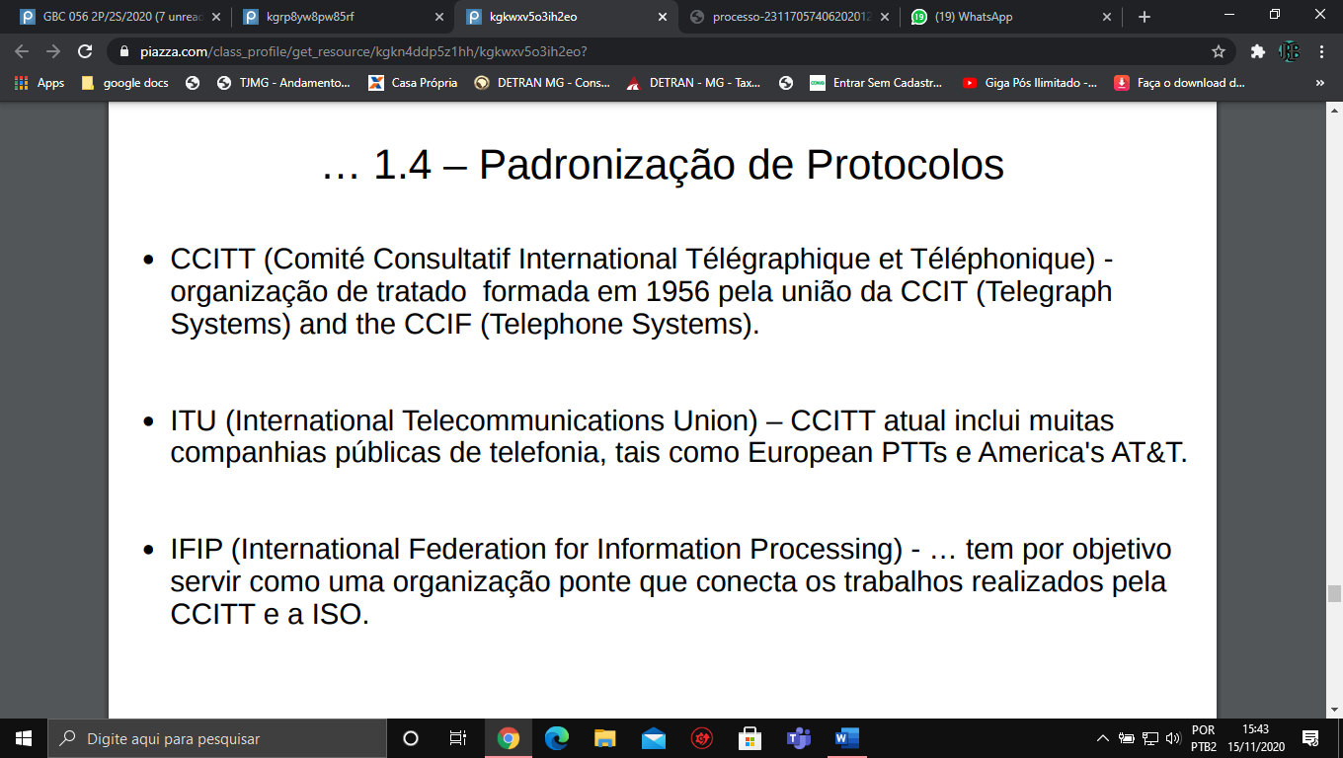

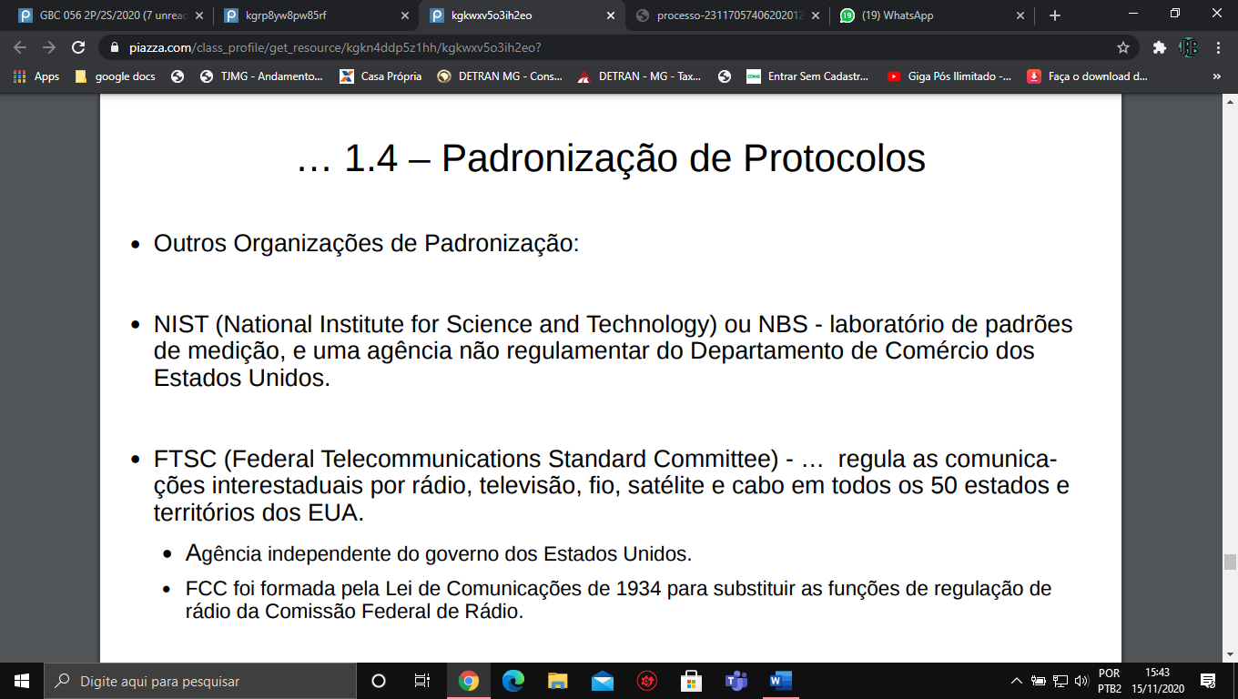

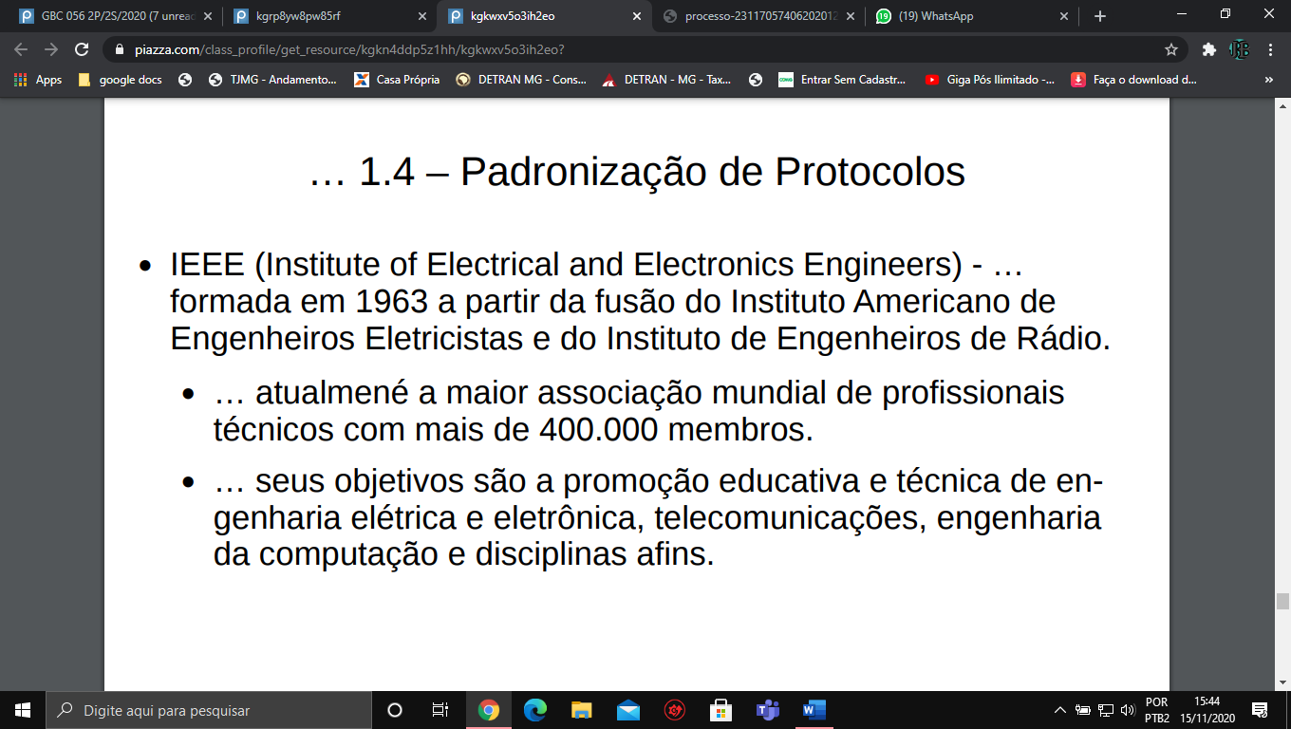

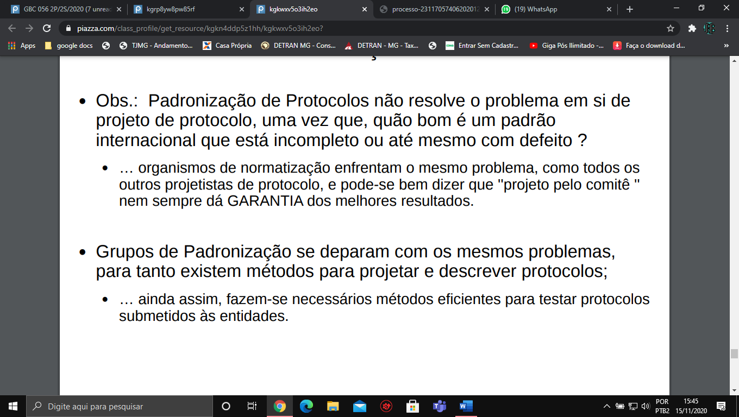

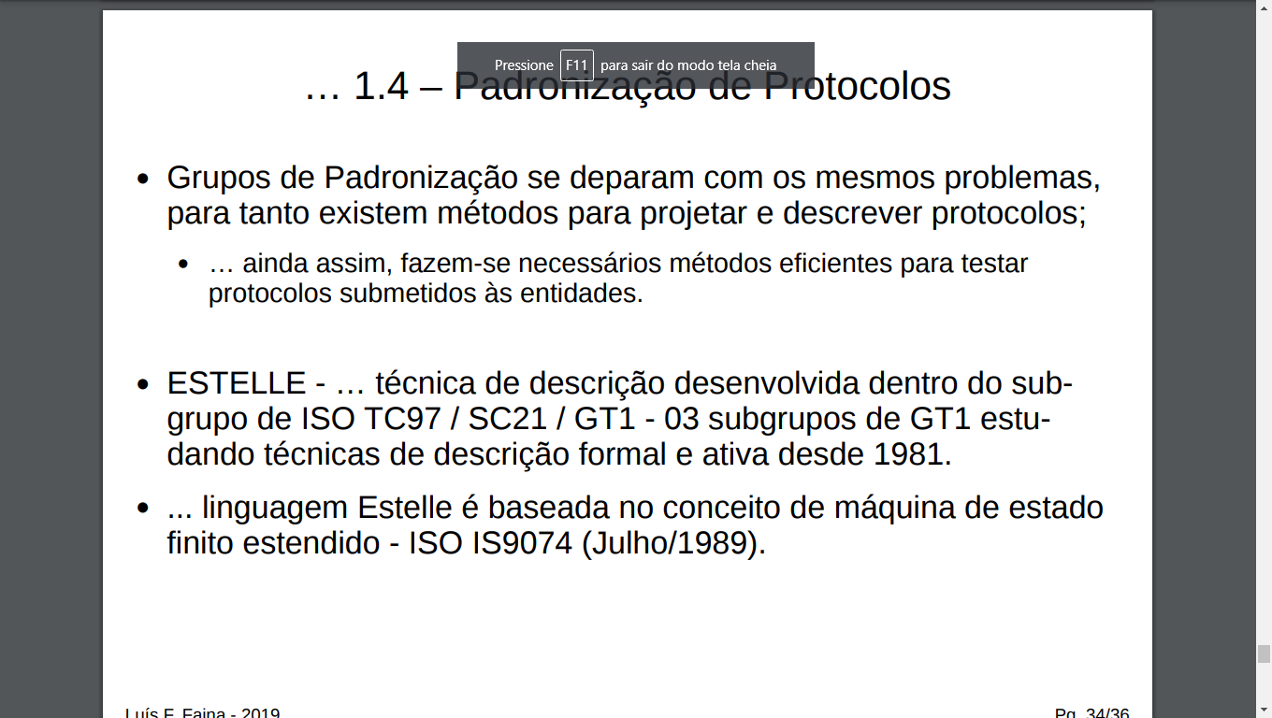

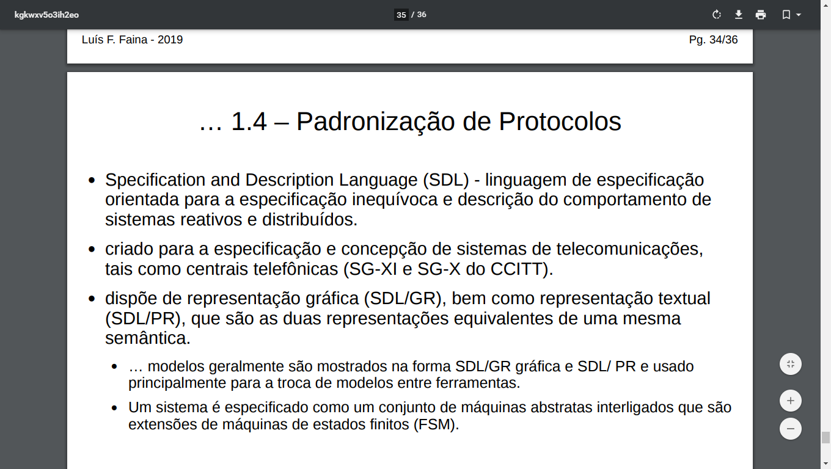

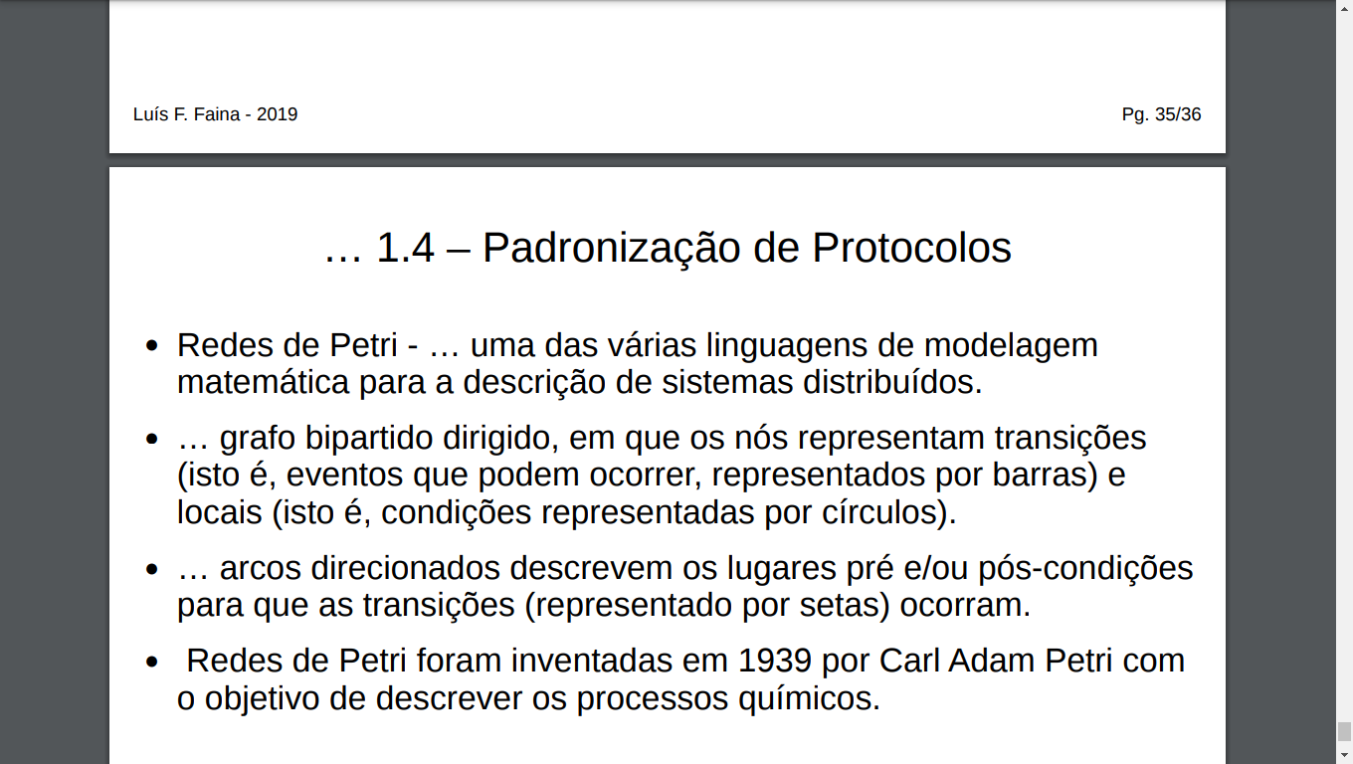

Vocabulário de protocolo

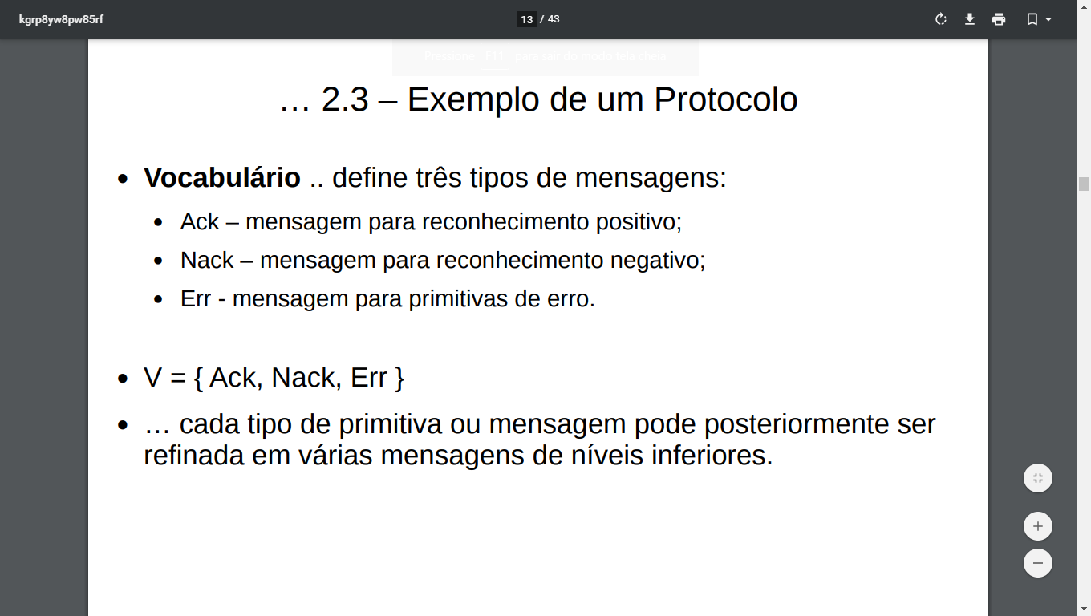

Sintaxe/formato

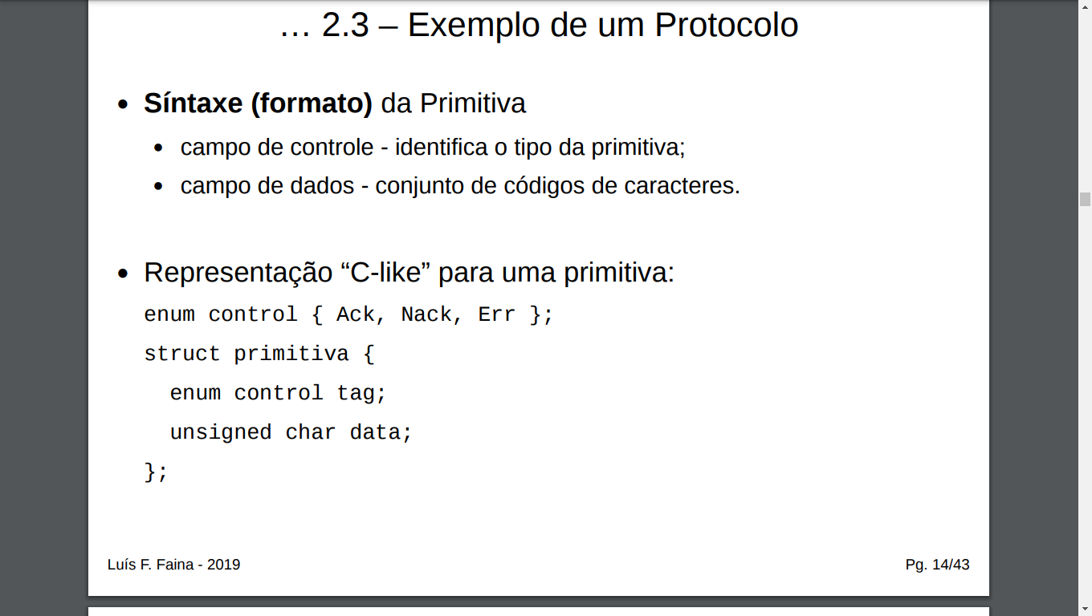

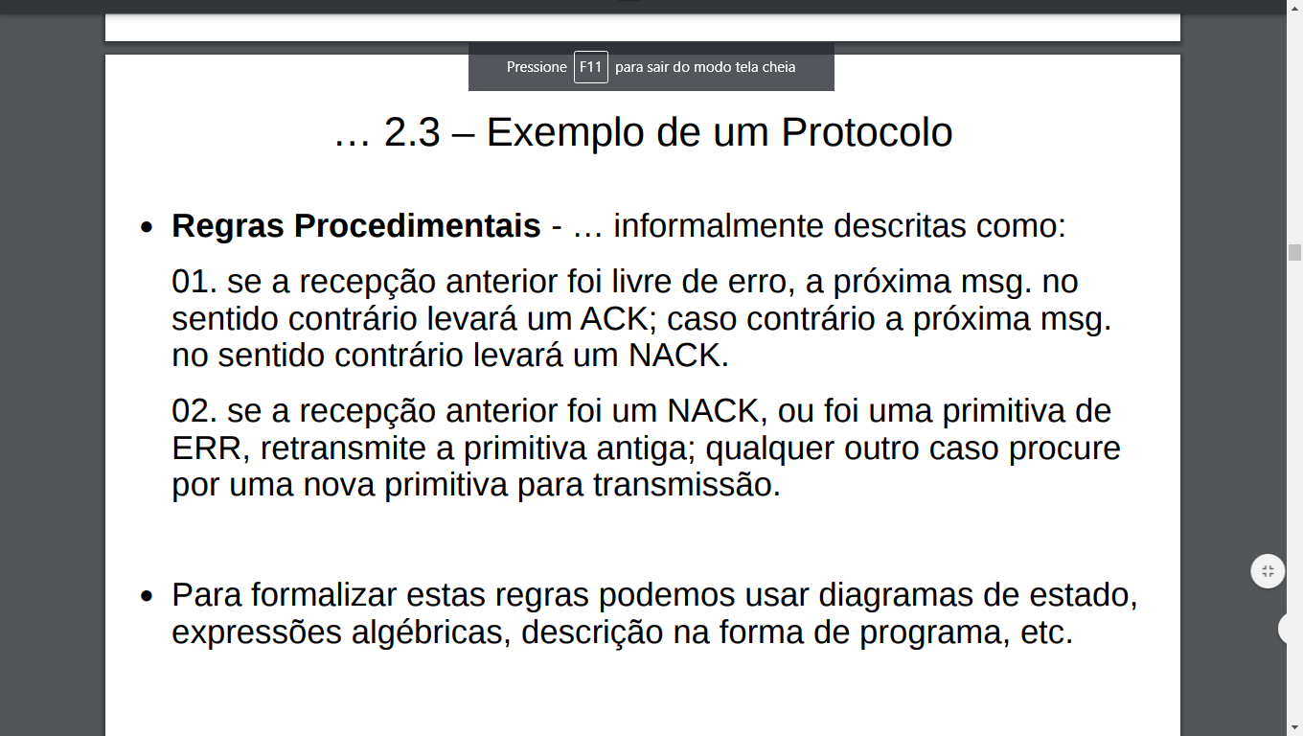

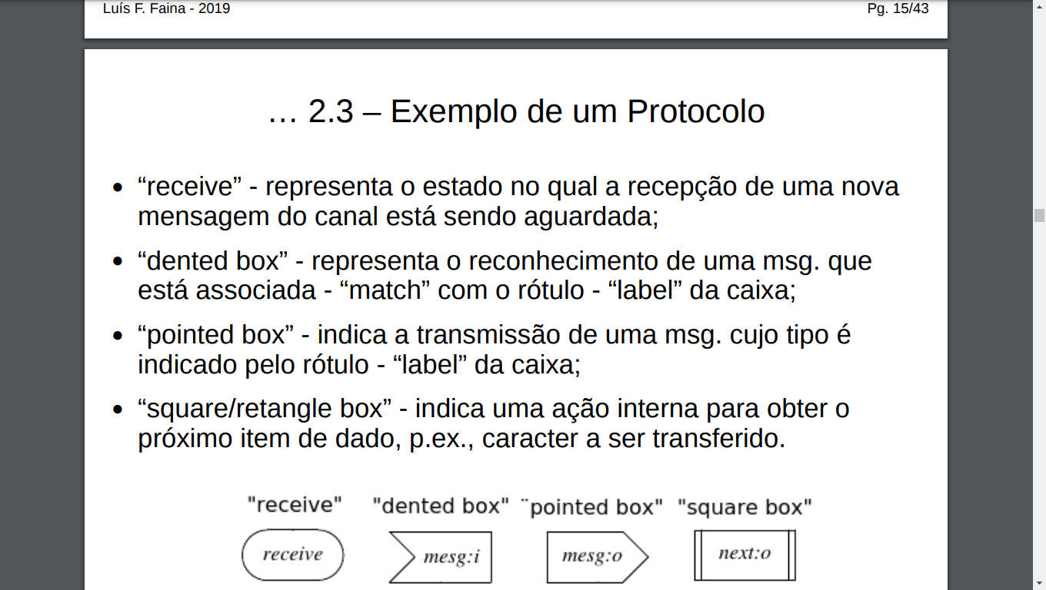

Diagrama de fluxo

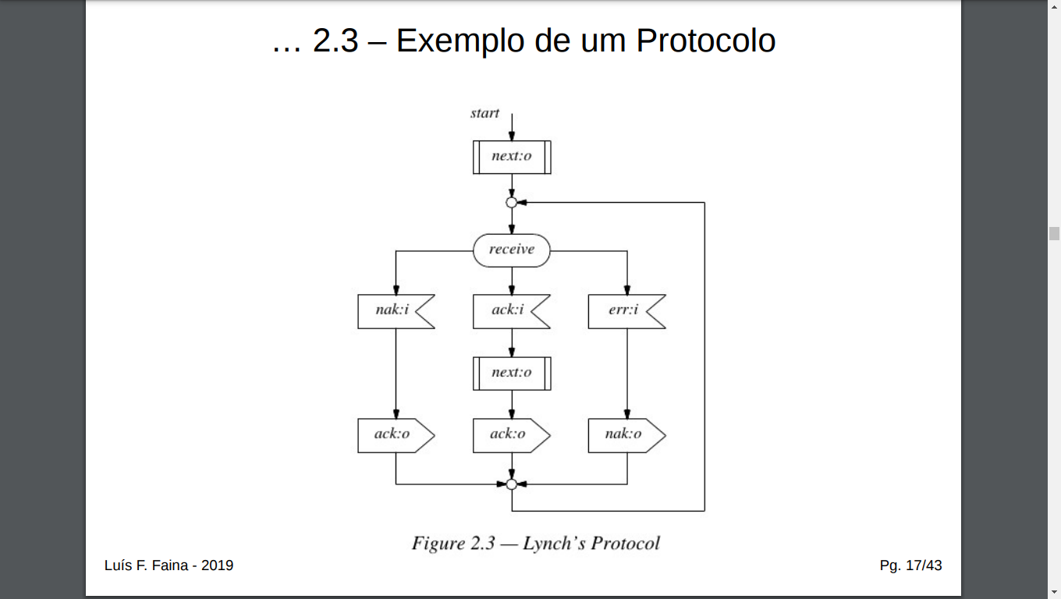

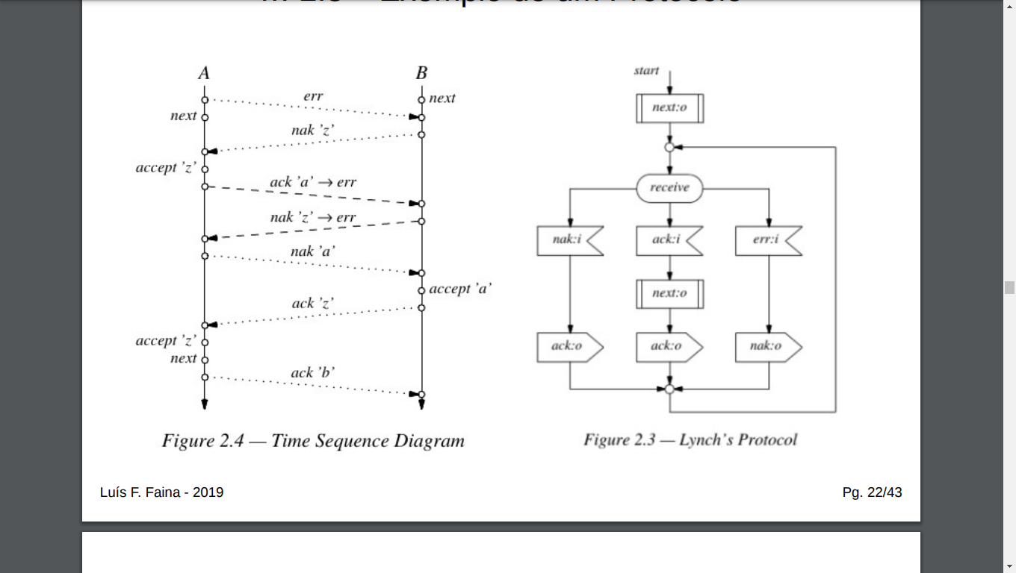

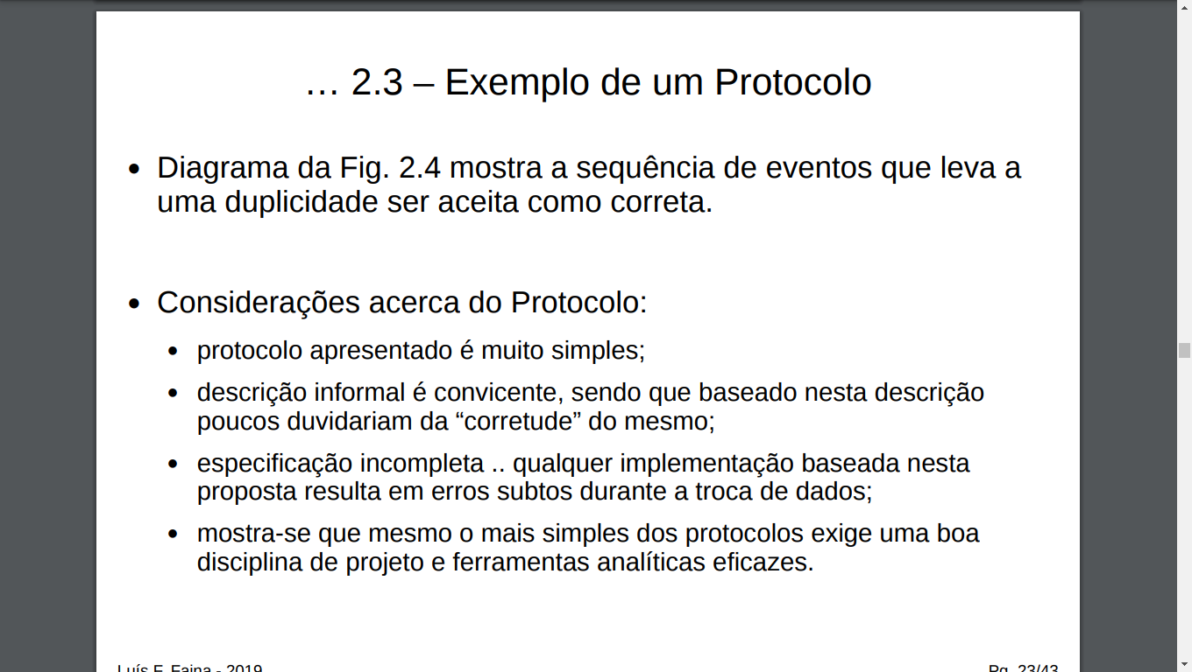

Cabeçalho e calda

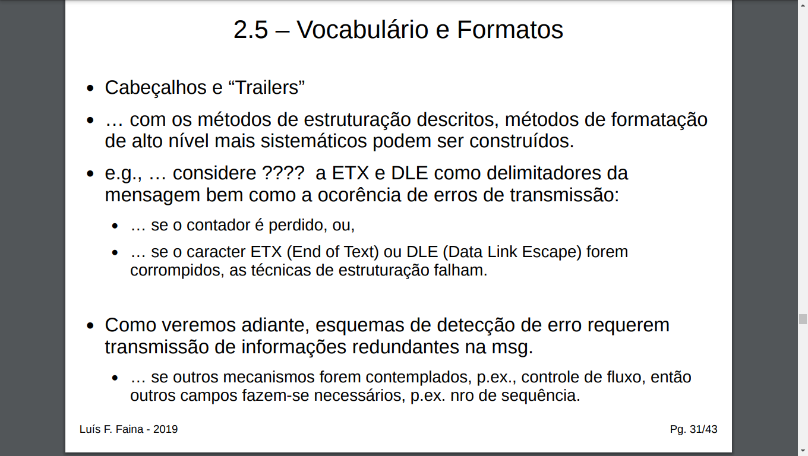

The transmission code developed by Polybius for his torch telegraph divided the 24-letter Greek alphabet into five groups. The first four groups had five letters each, and the fifth group had the remaining four. The telegraph worked with two groups of torches: one was used to encode the group number, the other to transmit the character number within that group. Transmission took place character by character, by raising and lowering torches in the two groups. There were no codes for spaces to separate words, nor for any kind of punctuation. (Punctuation was not used yet in written Greek either.) There was, however, one additional control message to signal the start of a message: two torches raised simultaneously (see the quotation from Polybius on page 2). What are the possible synchronization problems, in the absence of a proper agreement on the order in which the torches in the two groups are to be lowered and raised?

Ocasionar acidentes pois poderam bater

Estimate the transmission speed of the torch telegraph and compare it with Chappe’s system. How long does it take to transmit the message ‘‘protocol failure?’’

Telegrafo e mais lento

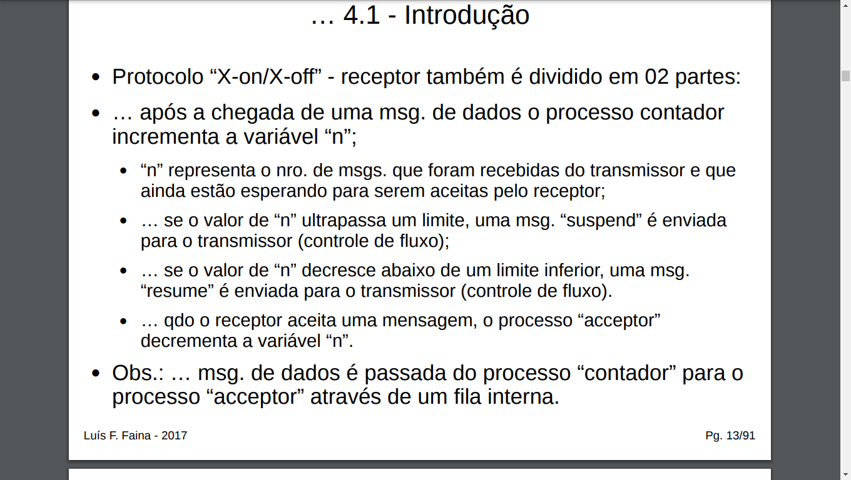

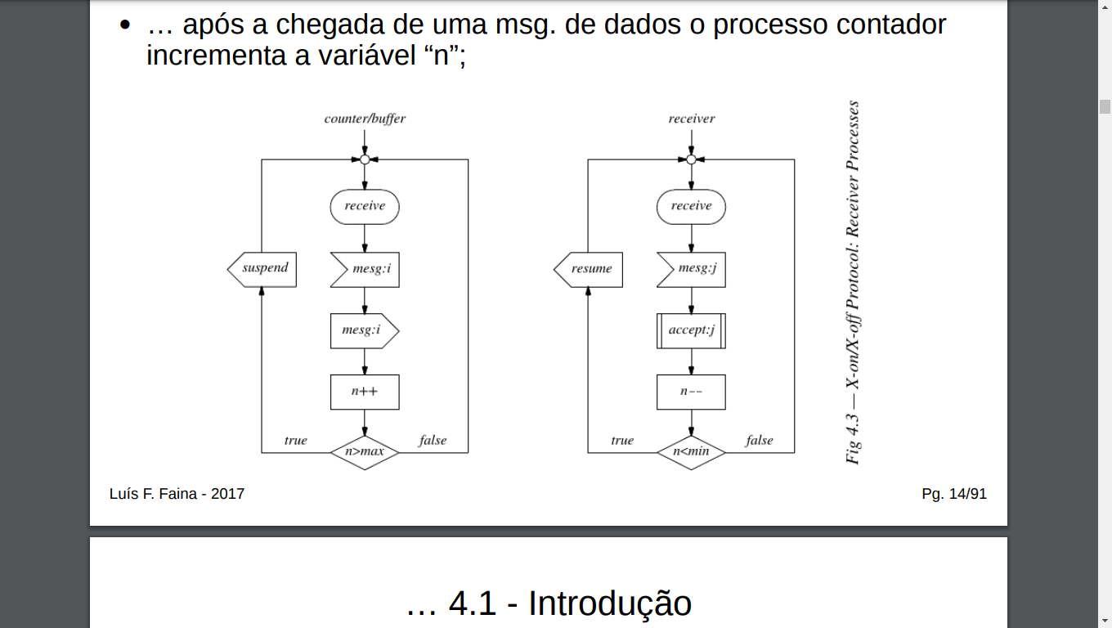

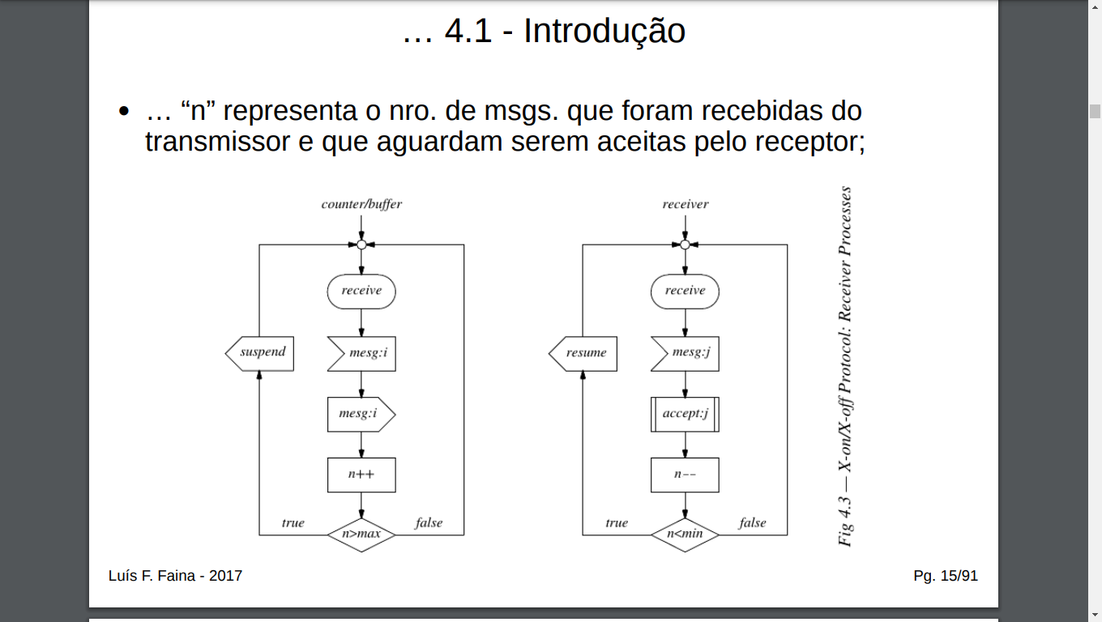

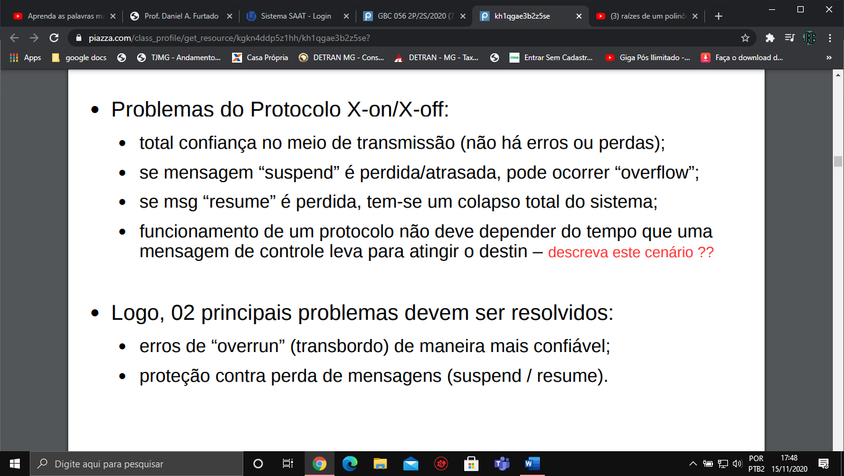

Protocolo stop-and-wat or ping-pong cap 4 pag 20

regras de ouro para um projeto de protocolo

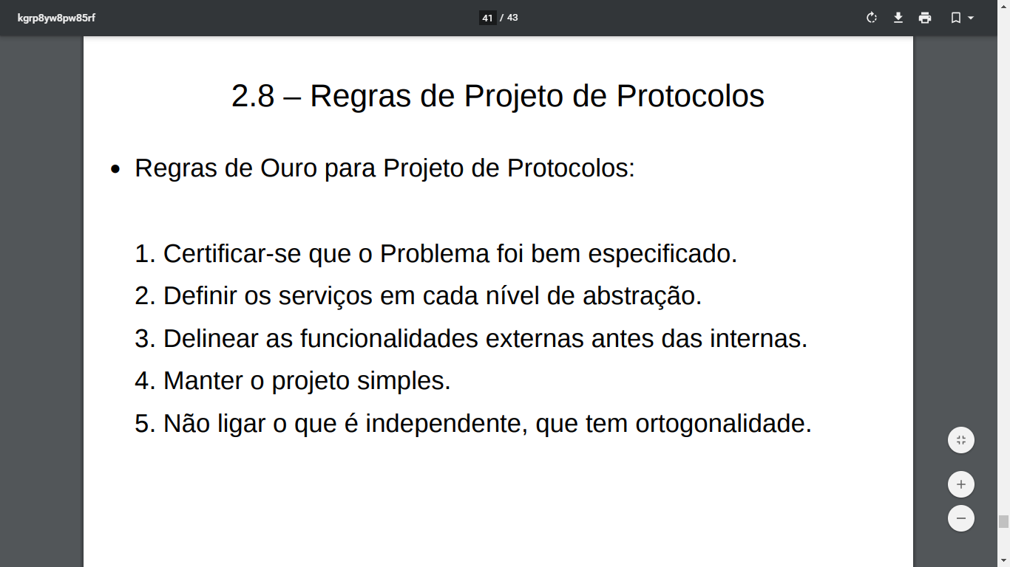

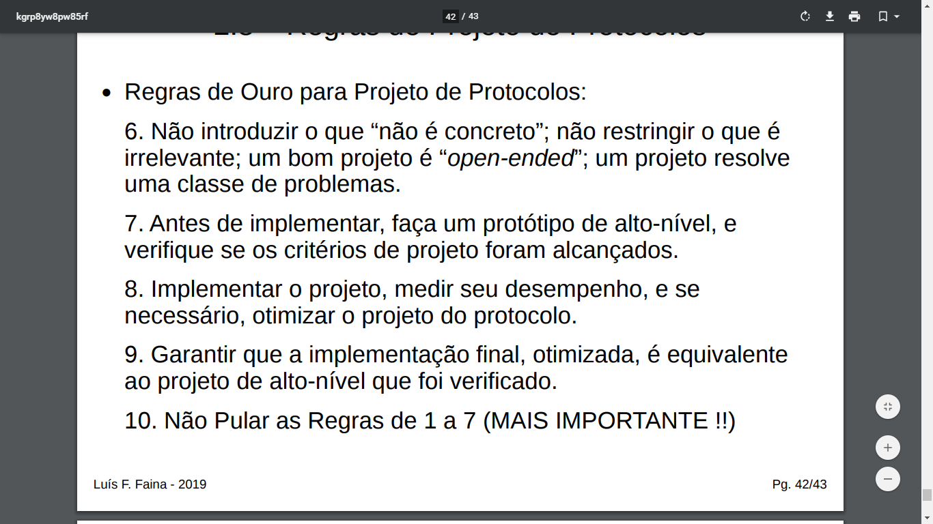

conta para descobrir taxa de erros de um protocolo

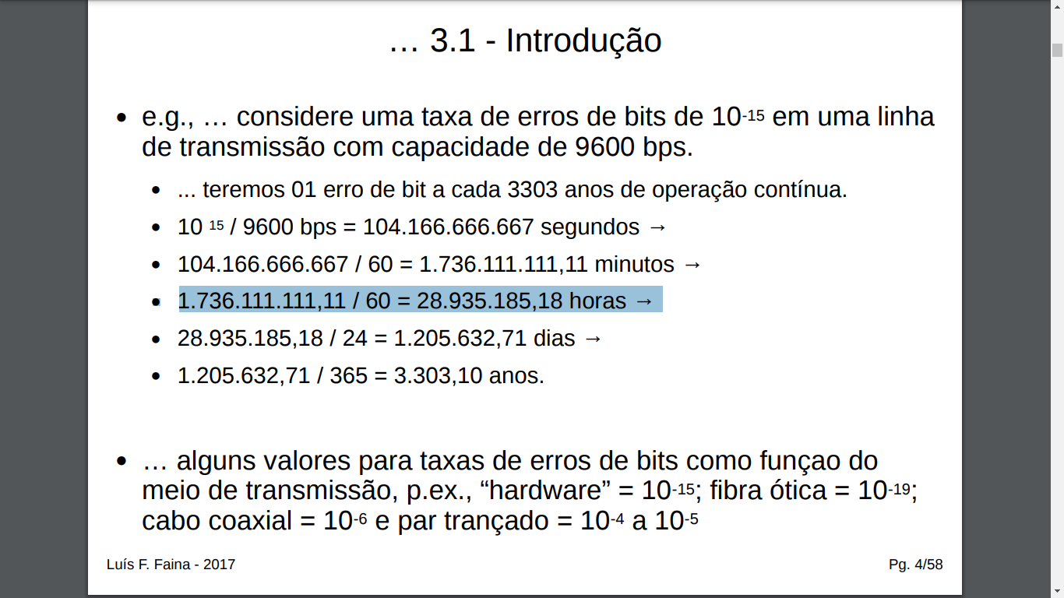

Estrutura de numero de sequencia

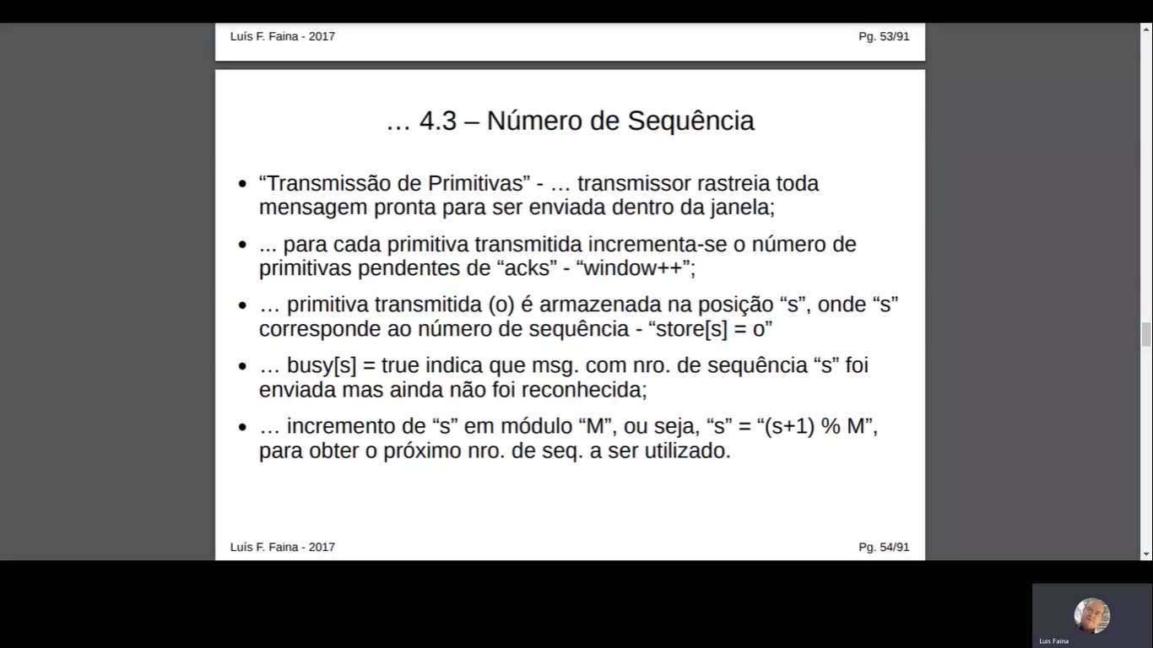

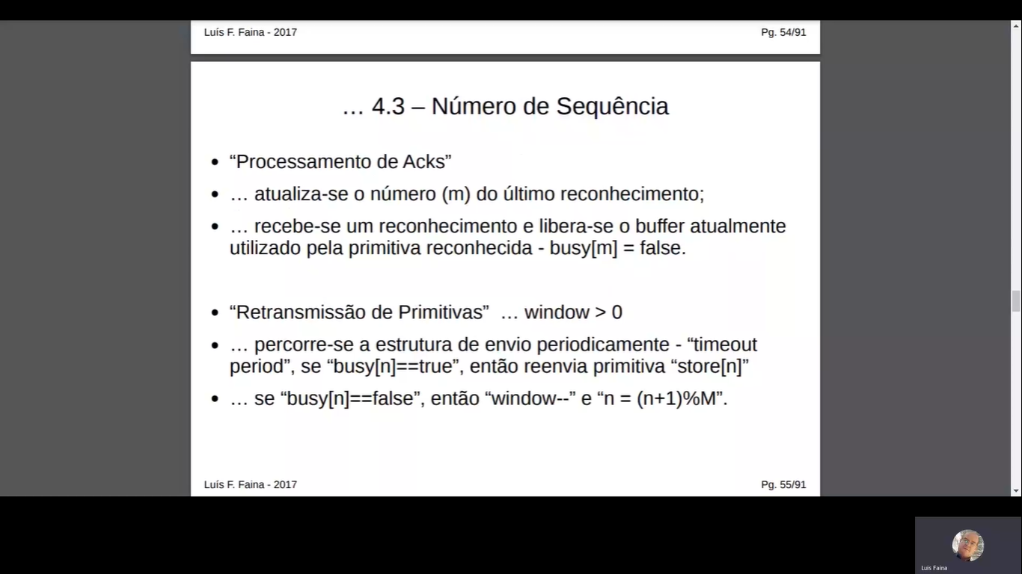

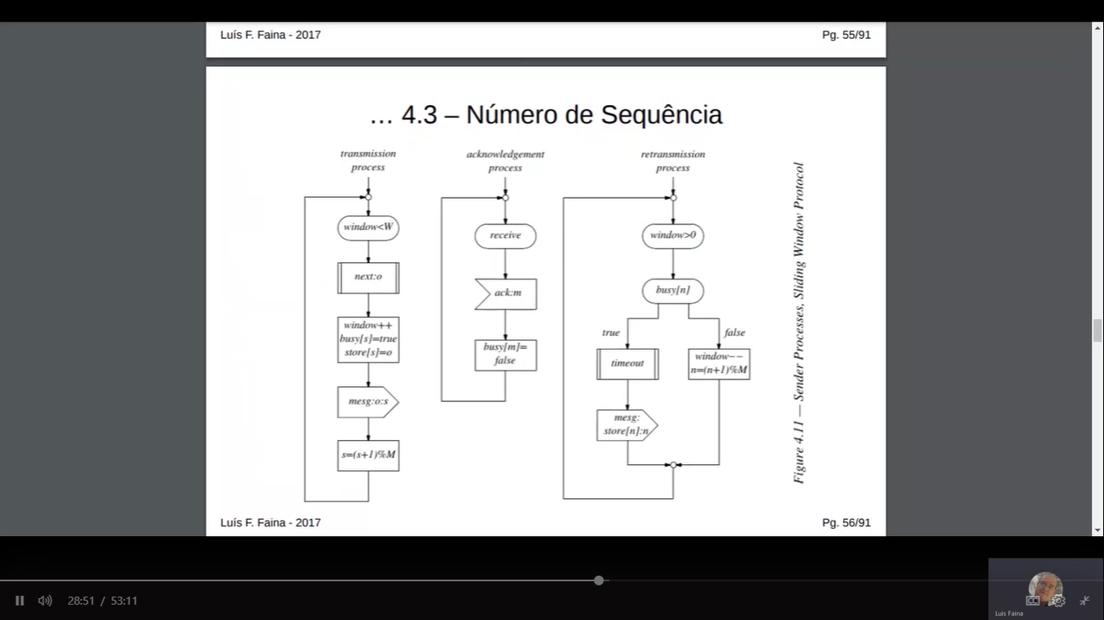

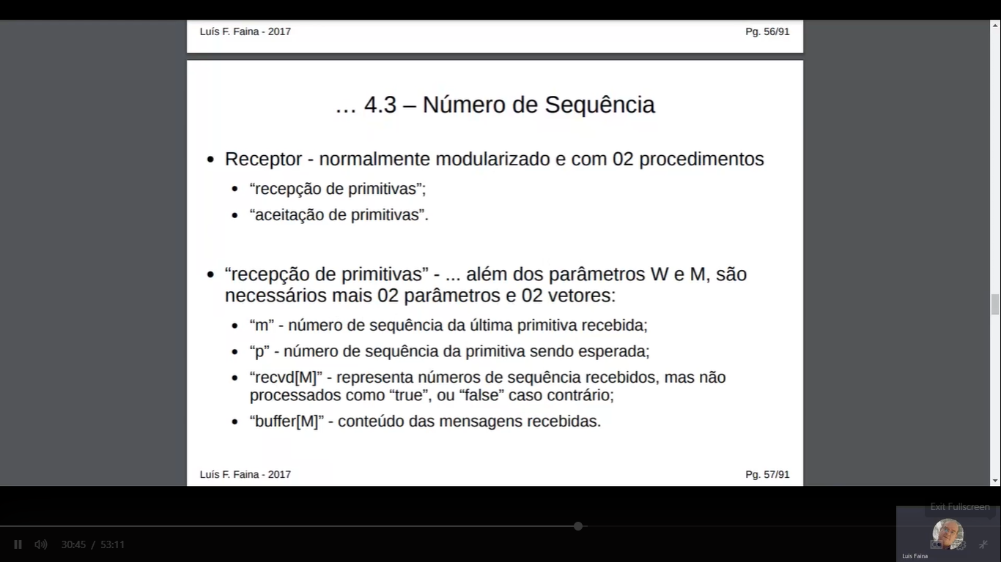

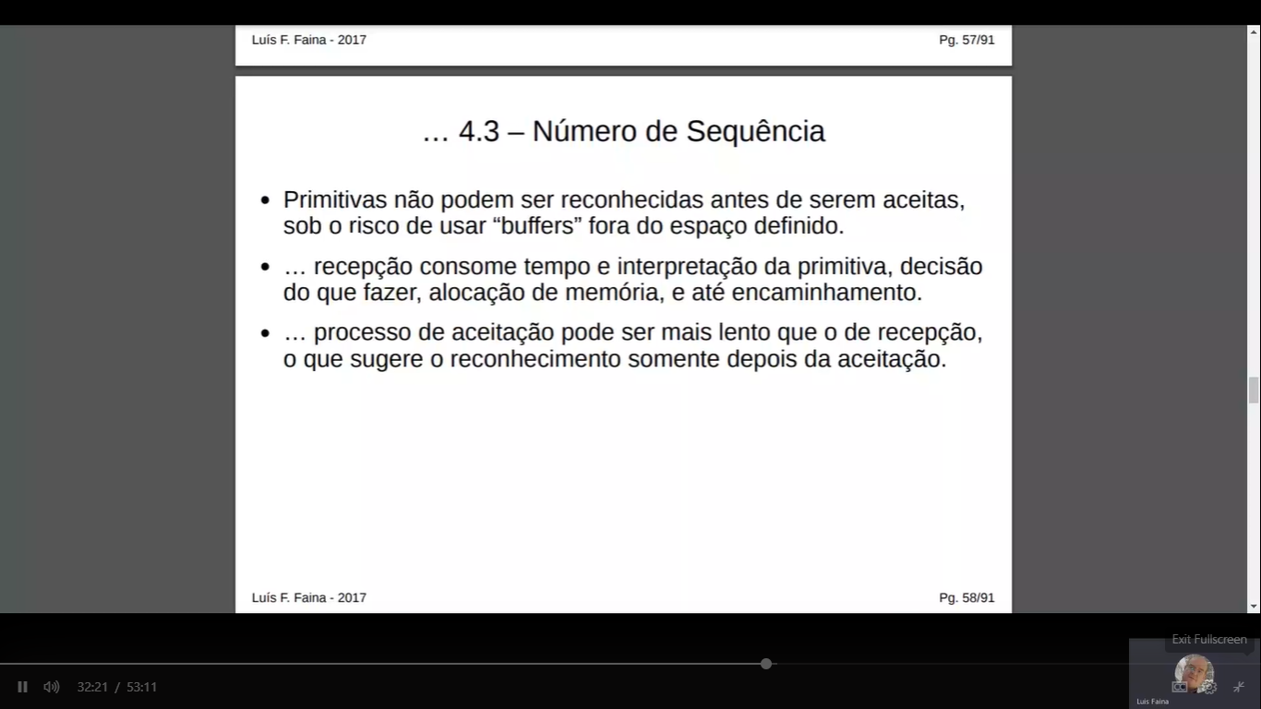

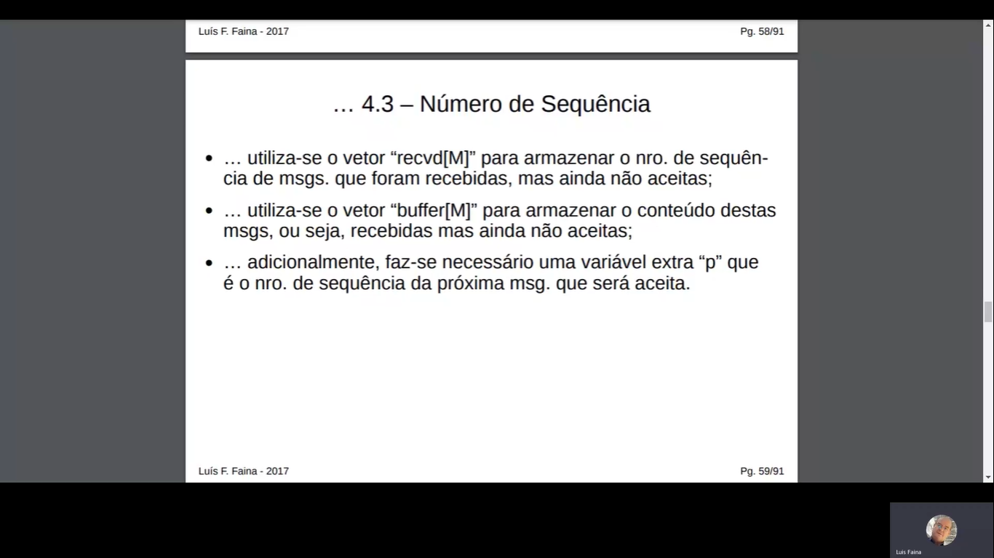

Recepção de primitivas lado esquerdo

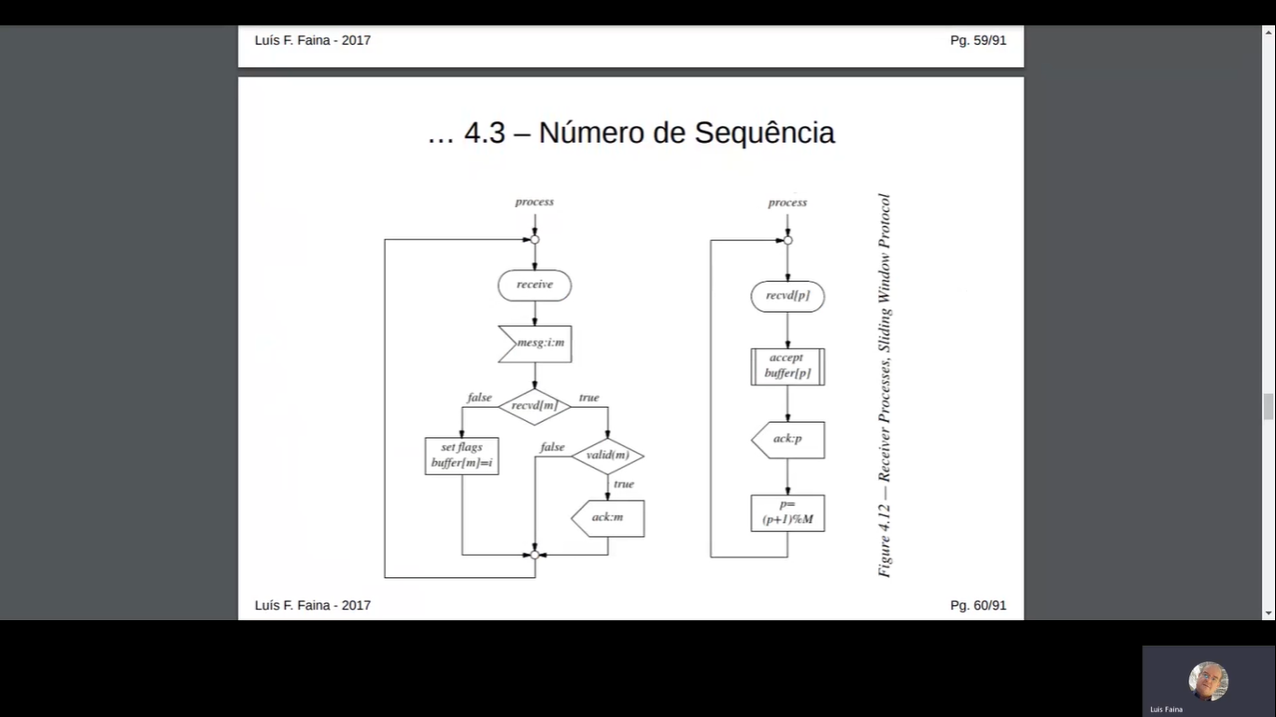

Ping pong

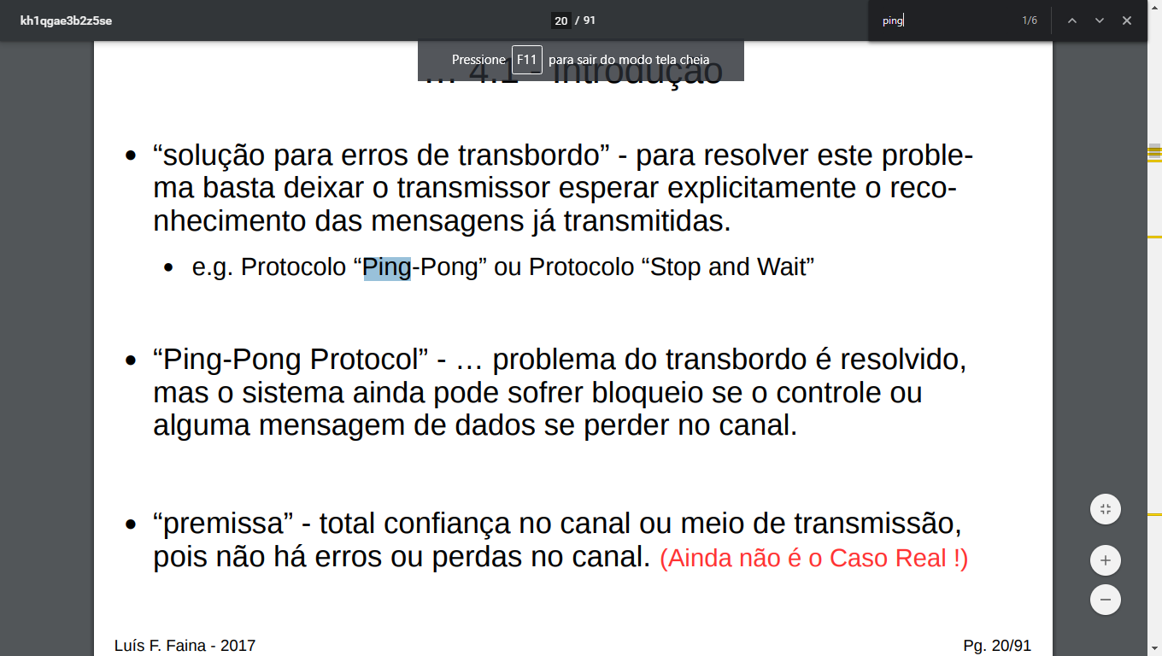

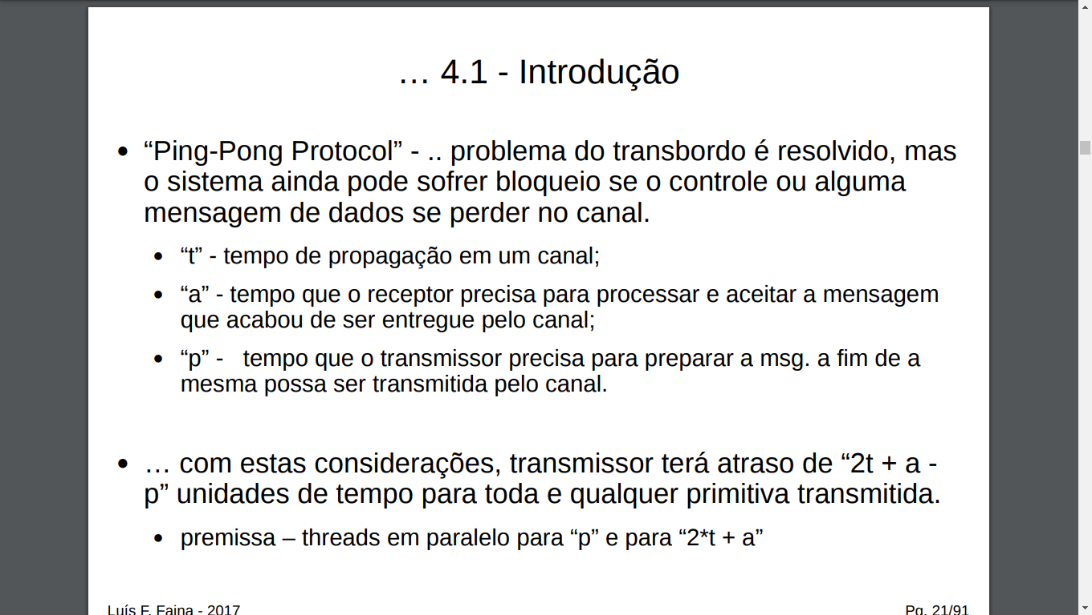

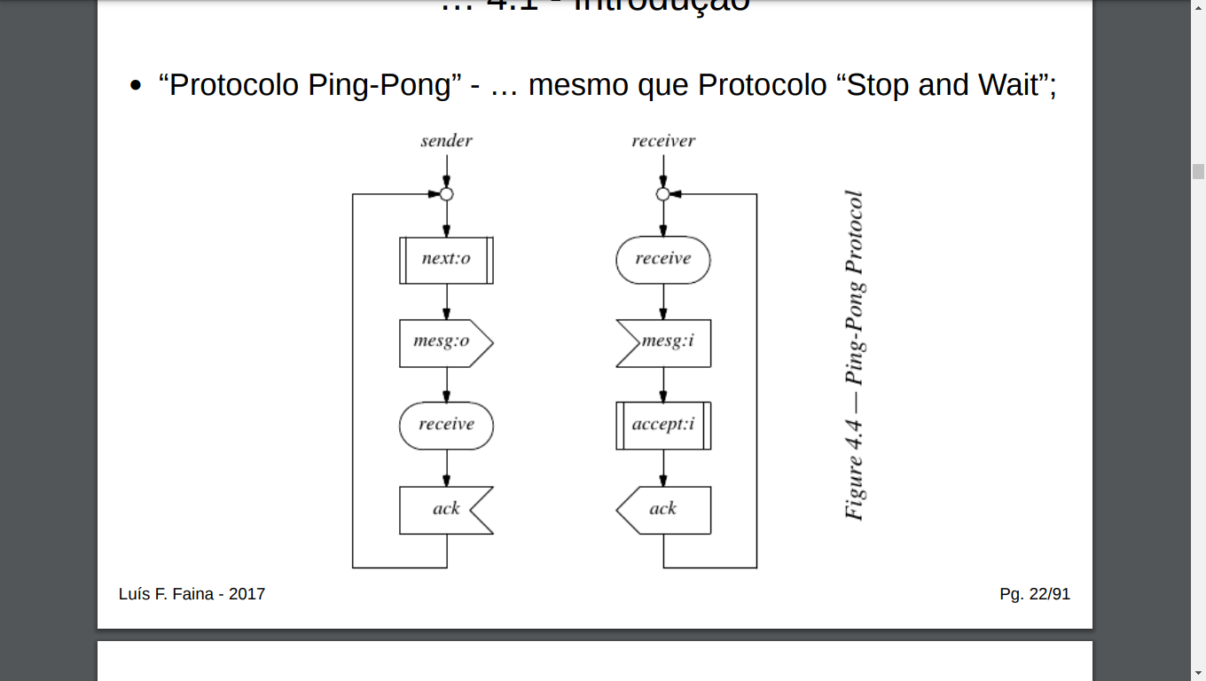

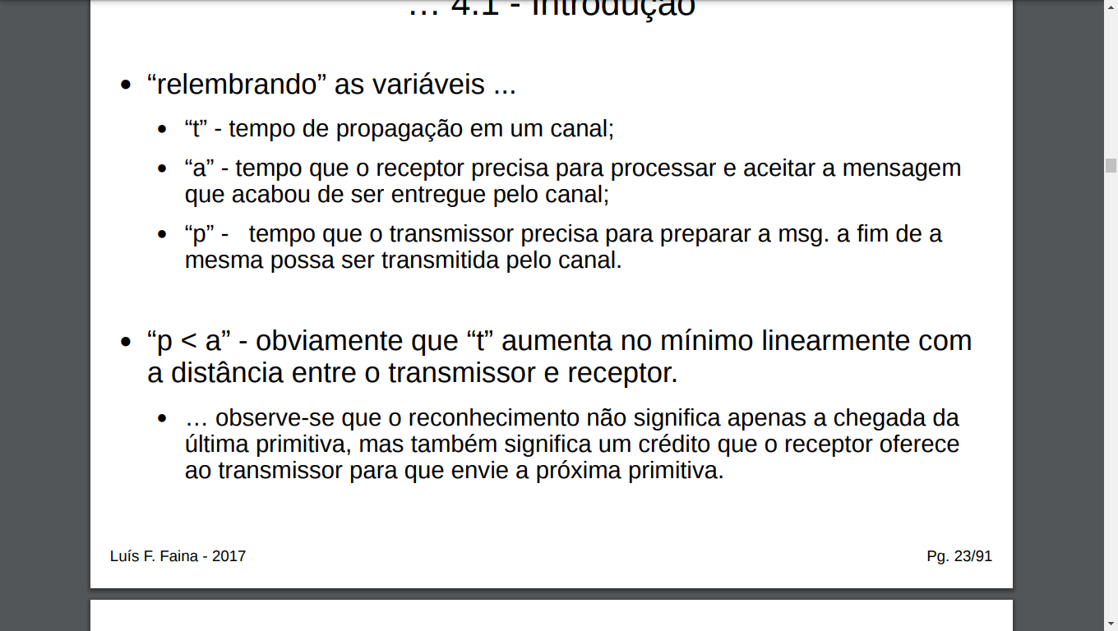

x-on/ x-off

